

**DEPARTMENT OF**

**COMPUTER SCIENCE AND ENGINEERING**

**Personal Portfolio Website**

UI/UX Design Fundamental

B. Tech Degree – 3 BTCS Section B

**School of Engineering and Technology,**

**CHRIST (Deemed to be University),**

**Kumbalagodu, Bengaluru-560 074**

September 2025



***Certificate***

*This is to certify that Chris Kevin A(2460349), Kevin Patrick K(2460419), Kavin M(2460391) has successfully completed the Project work for UI/UX Design Fundamental in partial fulfillment for the award of Bachelor of Technology during the academic year 2025-2026.*

*Mrs Nagaveena*

**FACULTY- IN CHARGE**

Name : Chris Kevin A.Patrick Kevin k, Kavin M

Register No. : 2460349,2460419,2460391

E-mail id : chris.kevina@btech.christuniversity.in , [Patrick.kevin@btech.christuniversity.in](mailto:Patrick.kevin@btech.christuniversity.in), kavin.m@btech.christuniversity.in

Date :25/09/2025

Institution :SoET, Christ University(Kengeri Campus)

# INDEX

|  |  |
| --- | --- |
| **SI. No** | **Contents** |
| **1** | **Abstract** |
| **2** | **Objective** |
| **3** | **Scope of Project** |
| **4** | **Tools and Technologies used** |
| **5** | **HTML Structure Overview** |
| **6** | **CSS Styling Strategy** |
| **7** | **Key Features** |
| **8** | **Challenges Faced & Solutions** |
| **9** | **Outcome** |
| **10** | **Future Enhancement** |
| **11** | **Sample Code** |
| **12** | **Final Output** |
| **13** | **Conclusion** |
| **14** | **References** |

## 1.Abstract

### This project is a personal portfolio website designed to showcase skills, projects, and contact information. The website acts as a professional digital introduction, highlighting expertise, past work, and providing a direct channel for communication. Built using HTML, CSS, JavaScript, Bootstrap, and jQuery, the site ensures responsiveness and accessibility across devices.

### 2. Objective

The primary objectives of this project are:

* To create a professional personal portfolio website.
* To present skills, projects, and experience in an interactive format.
* To allow potential clients or employers to contact the developer easily.

**3. Scope of Project**

* The scope of this project goes beyond just displaying images.
* Individual professionals and freelancers can showcase their work.
* Can be extended for businesses, agencies, or creative studios.
* Provides a platform to demonstrate technical and design skills.

### 4. Tools and Technologies Used

* **HTML5** – for website structure
* **CSS3** – for styling and design
* **Bootstrap 5** – for responsive grid and UI components
* **JavaScript & jQuery** – for interactivity and form validation
* **Google Fonts** – for custom typography

### 5. HTML Structure Overview

1. Header **/ Navbar** → Navigation links
2. Hero **Section** → Introduction & tagline
3. About **Me Section** → Biography & profile picture
4. Portfolio **Section** → Showcase of projects in cards
5. Contact **Form** → User can send inquiries
6. Footer → Copyright & social links

### 6. CSS Styling Strategy

* Used **Bootstrap utility classes** for grid, spacing, and responsiveness.
* Created a **custom style.css** for branding colors, hover effects, and hero background.
* Added smooth scrolling and hover animations for better UX.

### 7. Key Features

* **Responsive Design** → Works on desktop, tablet, and mobile.
* **Portfolio Gallery** → Organized showcase of work.
* **Contact Form** → Collects name, email, and message.
* **Smooth Navigation** → Sticky navbar with scroll effect.

### 8. Challenges Faced & Solutions

* **Challenge:** Ensuring responsiveness across devices.
* *Solution:* Used Bootstrap grid system and img-fluid.
* **Challenge:** Making the contact form interactive.
* *Solution:* Added jQuery for form validation and reset; can integrate EmailJS.
* **Challenge:** Designing a modern, professional look.
* *Solution:* Used Google Fonts, custom CSS, and hover animations.

### 9. Outcome

The final website is a responsive, professional portfolio that showcases skills, projects, and enables direct contact. It can be hosted online as a personal branding tool.

### 10. Future Enhancement

* Integration with a backend (PHP/Node.js) or **EmailJS** for live email sending.
* Adding a **downloadable resume (PDF)**.
* Expanding the portfolio section with categories & filters.
* Adding a **dark mode toggle**.
* SEO optimization for better discoverability.

### 11. Sample Code

**index.html**

<!DOCTYPE html>

<html lang="en">

<head>

  <meta charset="UTF-8">

  <meta name="viewport" content="width=device-width, initial-scale=1.0">

  <title>My Portfolio</title>

  <!-- Bootstrap CSS -->

  <link href="https://cdn.jsdelivr.net/npm/bootstrap@5.3.2/dist/css/bootstrap.min.css" rel="stylesheet">

  <!-- Custom CSS -->

  <link rel="stylesheet" href="style.css">

  <!-- Google Fonts -->

  <link href="https://fonts.googleapis.com/css2?family=Poppins:wght@400;600&display=swap" rel="stylesheet">

</head>

<body>

  <!-- Navbar -->

  <nav class="navbar navbar-expand-lg navbar-dark bg-dark sticky-top">

    <div class="container">

      <a class="navbar-brand fw-bold" href="#">MyPortfolio</a>

      <button class="navbar-toggler" type="button" data-bs-toggle="collapse" data-bs-target="#navbarNav">

        <span class="navbar-toggler-icon"></span>

      </button>

      <div class="collapse navbar-collapse" id="navbarNav">

        <ul class="navbar-nav ms-auto">

          <li class="nav-item"><a class="nav-link" href="#about">About Me</a></li>

          <li class="nav-item"><a class="nav-link" href="#portfolio">Portfolio</a></li>

          <li class="nav-item"><a class="nav-link" href="#contact">Contact</a></li>

        </ul>

      </div>

    </div>

  </nav>

  <!-- Hero Section -->

  <header class="hero text-white d-flex align-items-center">

    <div class="container text-center">

      <h1 class="fw-bold">Hello, I'm <span class="highlight">Spark</span></h1>

      <p class="lead">Web Developer | Designer | Freelancer</p>

      <a href="#portfolio" class="btn btn-primary mt-3">View My Work</a>

    </div>

  </header>

  <!-- About Section -->

  <section id="about" class="py-5">

    <div class="container">

      <h2 class="text-center mb-4">About Me</h2>

      <div class="row align-items-center">

        <div class="col-md-4 text-center">

          <img src="https://via.placeholder.com/250" class="rounded-circle img-fluid" alt="Profile Picture">

        </div>

        <div class="col-md-8">

          <p>Hello! I'm a passionate web developer with experience in creating dynamic and responsive websites. I specialize in front-end development using HTML, CSS, JavaScript, Bootstrap, and jQuery. My goal is to deliver clean, user-friendly designs that provide excellent user experiences. I enjoy learning new technologies and continuously improving my skills.</p>

        </div>

      </div>

    </div>

  </section>

  <!-- Portfolio Section -->

  <section id="portfolio" class="py-5 bg-light">

    <div class="container">

      <h2 class="text-center mb-4">My Portfolio</h2>

      <div class="row g-4">

        <div class="col-md-4">

          <div class="card shadow-sm">

            <img src="https://via.placeholder.com/400x250" class="card-img-top" alt="Project 1">

            <div class="card-body">

              <h5 class="card-title">Project One</h5>

              <p class="card-text">A web design project showcasing responsive UI.</p>

              <a href="#" class="btn btn-outline-primary btn-sm">View Project</a>

            </div>

          </div>

        </div>

        <div class="col-md-4">

          <div class="card shadow-sm">

            <img src="https://via.placeholder.com/400x250" class="card-img-top" alt="Project 2">

            <div class="card-body">

              <h5 class="card-title">Project Two</h5>

              <p class="card-text">A development project with dynamic features.</p>

              <a href="#" class="btn btn-outline-primary btn-sm">View Project</a>

            </div>

          </div>

        </div>

        <div class="col-md-4">

          <div class="card shadow-sm">

            <img src="https://via.placeholder.com/400x250" class="card-img-top" alt="Project 3">

            <div class="card-body">

              <h5 class="card-title">Project Three</h5>

              <p class="card-text">A creative design with modern aesthetics.</p>

              <a href="#" class="btn btn-outline-primary btn-sm">View Project</a>

            </div>

          </div>

        </div>

      </div>

    </div>

  </section>

  <!-- Contact Section -->

  <section id="contact" class="py-5">

    <div class="container">

      <h2 class="text-center mb-4">Contact Me</h2>

      <div class="row justify-content-center">

        <div class="col-md-8">

          <form id="contactForm">

            <div class="mb-3">

              <label for="name" class="form-label">Your Name</label>

              <input type="text" class="form-control" id="name" required>

            </div>

            <div class="mb-3">

              <label for="email" class="form-label">Your Email</label>

              <input type="email" class="form-control" id="email" required>

            </div>

            <div class="mb-3">

              <label for="message" class="form-label">Your Message</label>

              <textarea class="form-control" id="message" rows="4" required></textarea>

            </div>

            <button type="submit" class="btn btn-primary w-100">Send Message</button>

          </form>

        </div>

      </div>

    </div>

  </section>

  <!-- Footer -->

  <footer class="bg-dark text-white text-center py-3">

    <p class="mb-0">&copy; 2025 MyPortfolio | Designed by Me</p>

  </footer>

  <!-- Bootstrap JS & jQuery -->

  <script src="https://code.jquery.com/jquery-3.7.1.min.js"></script>

  <script src="https://cdn.jsdelivr.net/npm/bootstrap@5.3.2/dist/js/bootstrap.bundle.min.js"></script>

  <script>

    // jQuery Contact Form Alert

    $("#contactForm").on("submit", function(e){

      e.preventDefault();

      alert("Thank you for reaching out! I will get back to you soon.");

      $(this).trigger("reset");

    });

  </script>

</body>

</html>

**style.css**

body {

  font-family: 'Poppins', sans-serif;

  line-height: 1.6;

}

.hero {

  background: url("https://via.placeholder.com/1600x600") center/cover no-repeat;

  height: 100vh;

  text-shadow: 2px 2px 5px rgba(0,0,0,0.6);

}

.hero .highlight {

  color: #ffc107;

}

section h2 {

  font-weight: 600;

  margin-bottom: 20px;

}

.card img {

  border-radius: 5px 5px 0 0;

}

### 12. Final Output

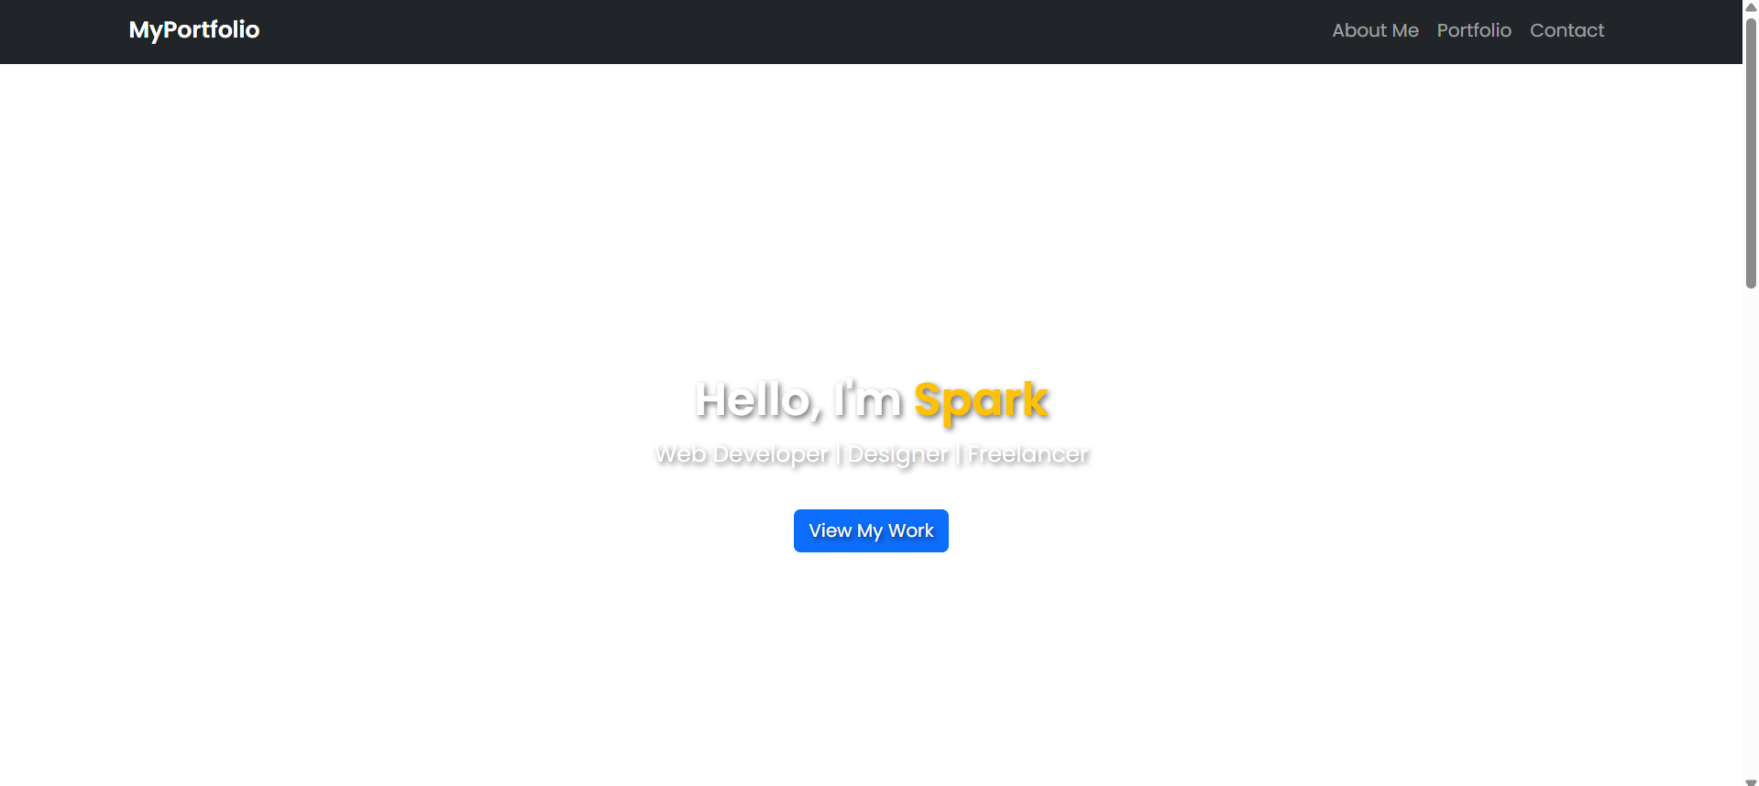

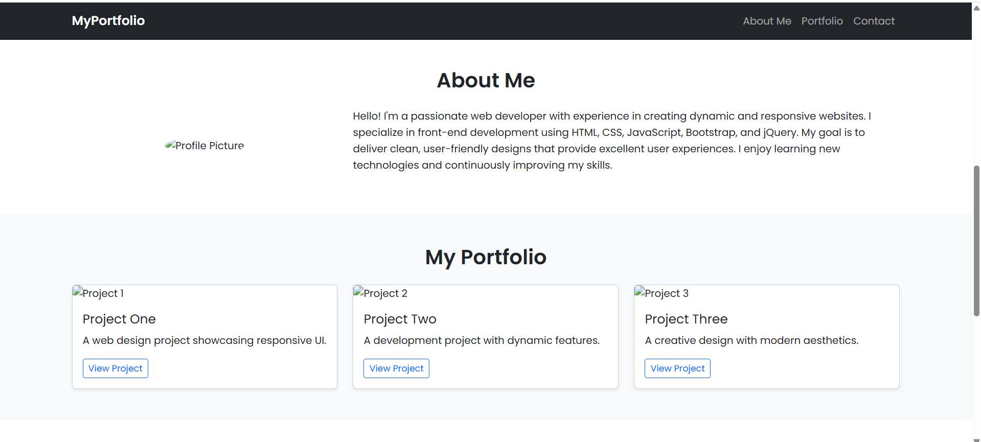

A fully responsive portfolio website with:

* Navbar
* Hero Section
* About Me Section
* Portfolio Gallery
* Contact Form
* Footer

#### 13. Conclusion

This project demonstrates how front-end web technologies can be used to create a professional and visually appealing portfolio website. It highlights the developer’s skills, projects, and provides a platform for future opportunities.

#### 14. References

* Bootstrap Documentation
* jQuery Documentation
* MDN Web Docs
* W3Schools
* [Unsplash](https://unsplash.com/) – Stock images
* Wallpapers.com – Backgrounds